|  |
| --- |
|  |
| iAstroHub 3.0 |
| Ultimate Mobile Platform for Astrophotography |

|  |
| --- |
| Richard Garanger and Anat Ruangrassamee  30/09/2016 |

Table of Contents

1 Introduction 5

1.1 What is iAstroHub? 5

1.2 Features 5

1.3 How does iAstroHub work?? 6

1.4 Software 6

1.4.1 Software structure 6

1.4.2 Required Software 8

1.5 Hardware 8

1.5.1 Supported hardware 8

1.5.2 Wiring Diagram 9

2. Quick start guide 10

2.1 Installation 10

2.2 Initial Setup 12

2.2.1 Autoguiding 12

2.2.2 Skychart 13

2.2.3 Setting file of SkySafari 13

2.3 First Light 13

3 Understanding Main Pages 15

3.1 Autoguiding 15

3.2 Camera control 17

3.2.1 DSLR Camera (Canon, Nikon, or Pentax) 17

3.2.2 QSI and SX Cameras 18

3.2.3 SBIG, ATIK, and QHY Cameras 19

3.2.4 INDI-Compatible Cameras and Devices 19

3.3 Plate-solving, sync, and link to SkySafari 24

3.4 Focuser 26

3.5 Flip-Flat 26

3.6 Skychart 27

4 Understanding the Admin Page 29

4.1 Autoguider and CCD Camera 29

4.2 DSLR Camera 30

4.3 Plate-solving 32

4.4 Mount Control and Skychart 32

4.5 Focuser 33

4.6 Pushover Notification 33

4.7 File Management 33

4.8 System 34

5. Useful links 39

# Introduction

## What is iAstroHub?

iAstroHub is the world's first mobile solution for astrophotography. A user can interact with all astrophotography devices from any mobile device using a web browser. iAstroHub is a software package embedded in ARM Linux platforms. **Raspberry Pi 3 (RPi3)** is used for iAstroHub 3.0.

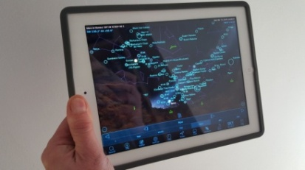[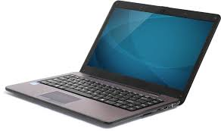](http://www.google.fr/imgres?imgurl=http://pngimg.com/upload/laptop_PNG5911.png&imgrefurl=http://pngimg.com/img/electronics/laptop&h=2072&w=3501&tbnid=IX0c4KgTvZEpHM:&zoom=1&docid=yFwRocLyO5IhnM&ei=zThBVdKMMML-aMPIgdAO&tbm=isch&iact=rc&uact=3&dur=694&page=3&start=30&ndsp=20&ved=0CKsBEK0DMCU)

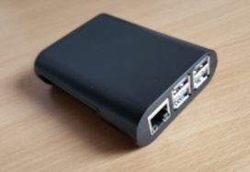

*Laptop Raspberry Pi 3 and tablet*

## Features

* only need a web browser on a mobile device to control everything! ( "i" stands for internet)
* control an autoguider
* control a DSLR camera (Canon, Nikon, and Pentax)
* control DSLR setting and Liveview via qDslrDashboard
* control a CCD camera and a filter wheel for imaging
* control a focuser
* control Flip-Flat for flat-fielder and lens cover
* show real-time guiding error graphs and alert logs
* preview images taken by a camera
* perform dithering between frames
* manipulate histogram of images from a CCD camera
* perform plate-solving using the standalone Astrometry.net engine
* re-align mount based on the position from plate solving
* show skychart and control mount from built-in Skychart (Cartes du Ciel)
* show a plate-solving result directly in Skysafari and re-align the mount from Skysafari
* support the control of a mount from Skysafari on iOS and Android
* save all images on a USB flash drive
* speak imaging progress
* push notification to smart phones or smart watches
* low power consumption
* small enough to be installed on the telescope
* open-source software

## How does iAstroHub work??

* iAstroHub is installed on RPi3.
* Astrophotograpy devices are connected to RPi3.
* iAstroHub will function as a web server with all engines running in background.
* A mobile phone or tablet can connect to iAstroHub directly. Control of all devices is done via a web browser.

## Software

### Software structure

The following figure shows the structure of iAstroHub.

Tablet

Windows PC

MobaXterm

Web browser

qDslrDashboard

SkySafari Plus or Pro

**RPi3**

**iAstroHub 3.0**

DslrDashboard  
server

Web server

Linguider

INDI

GoQat

OpenSky  
Imager

Gphoto2

Serial-TCP Bridge

Astrometry

Sky Chart

Erreur en Ascension droite

Raspbian - Linux

Hardware

ST4

Mount

Autoguider

CCD camera

DSLR

### Required Software

The following table summarizes the related software on a tablet or PC

|  |  |  |  |
| --- | --- | --- | --- |
| **Tablet** | **Required/ Optional** | **Price** |  |
| Web browser  (iOS and Android) | Required | $0 | To connect to iAstroHub. |
| Skysafari 5 Plus or Pro  (iOS and Android) | Optional | $15 / $40 | Planetarium software used for Go To and display of the plate-solving result |
| qDslrDashboard  (iOS and Android) | Optional | $10 | To set parameters in DSLR and display LiveView. |
| Pushover  (iOS and Android) | Optional | $5 | To get notifications |
| iINDI (iOS only) | Optional | $4 | To control INDI-compatible devices |
| **Windows PC** |  |  |  |
| 7-Zip | Required | $0 | To uncompress the .7z image file |
| Win32DriveImager | Required | $0 | To write the micro SD card |
| MobaXterm | Optional | $0 | To access to the RPi3 from a PC   * SSH terminal to use Linux commands * SFTP : Transfer the astrometry.net index files and other files. |

## 1.5 Hardware

### 1.5.1 Supported hardware

**Autoguiders**

Orion Starshoot autoguider, QHY5, QHY5-II, QHY5L-II, QHY6, ATIK, Starlight Xpress, ZWO ASI cameras

**DSLR Cameras**

Canon (since 300D) and Nikon (since D50) DSLR cameras. Pentax DSLR cameras (Refer to http://pktriggercord.melda.info/)

**CCD Cameras and Filter Wheels**

Native control with GoQat: QSI and Starlight Xpress

Native control with OpenSkyImager: SBIG, ATIK, and QHY (5, 5ii, 6, 8, 8L, 9, 10, 11,12, IC8300

INDI driver: FLI, Apogee, Moravian, ATIK, ZWO ASI, SX, SBIG, QSI, etc.

**Mounts**

Controlled by Skychart: mounts using LX200, iOptron, Nexstar/Skywatcher, TheSkyX protocols

Controlled by SkySafari: Almost all mounts are supported. Refer to <http://skysafariastronomy.com/>

**Focusers**

Native control: Robofocus

INDI driver: Robofocus, Moonlite, FocusLynx, etc.

### 1.5.2 Wiring Diagram

The following diagram is an example of the typical setup.

## 

|  |  |
| --- | --- |
| **No.** | **Details** |
| 1 | Raspberry Pi 3 and its enclosure |
| 2 | 16GB Class 10 micro SD card |
| 3 | Micro USB power cable |
| 4 | 12 -> 5V **3A** converter |
| 5 | Tablet or smartphone (Android or iOS) |
| 6 | PC for flashing the micro SD card |
| 7 | USB cable to connect to a camera |
| 8 | a DSLR or CCD camera |
| 9 | PL2303-based USB - RS232 converter (ATEN UC232A is recommended) |
| 10 | Serial cable to connect to a mount |
| 11 | Mount hand controller |
| 12 | USB cable to an autoguider |
| 13 | Autoguiding camera |
| 14 | ST4 cable to send guiding signal to the mount |
| 15 | Mount |

# 2. Quick start guide

## 2.1 Installation

* Download the image file from the URL provided in https://sourceforge.net/projects/iastrohub/
* Uncompress the file with **7-ZIP**
* Use **Win32DiskImager** to write the image to the micro SD card. Use a 16GB Class 10 card. SanDisk Ultra is recommended.
* Insert the micro SD card into the RPi3
* Power on the RPi3
* Connect via WIFI to RPi3 with a PC or a tablet/smartphone.   
  SSID = iAstroHub   
  Password = 1234512345123
* Use a web browser in your mobile device to access the web interface. Main web page is <http://10.0.0.1/> The following figures are the **main** page and the **admin** page. The main page may differ depending on the DSLR or CCD camera selected.

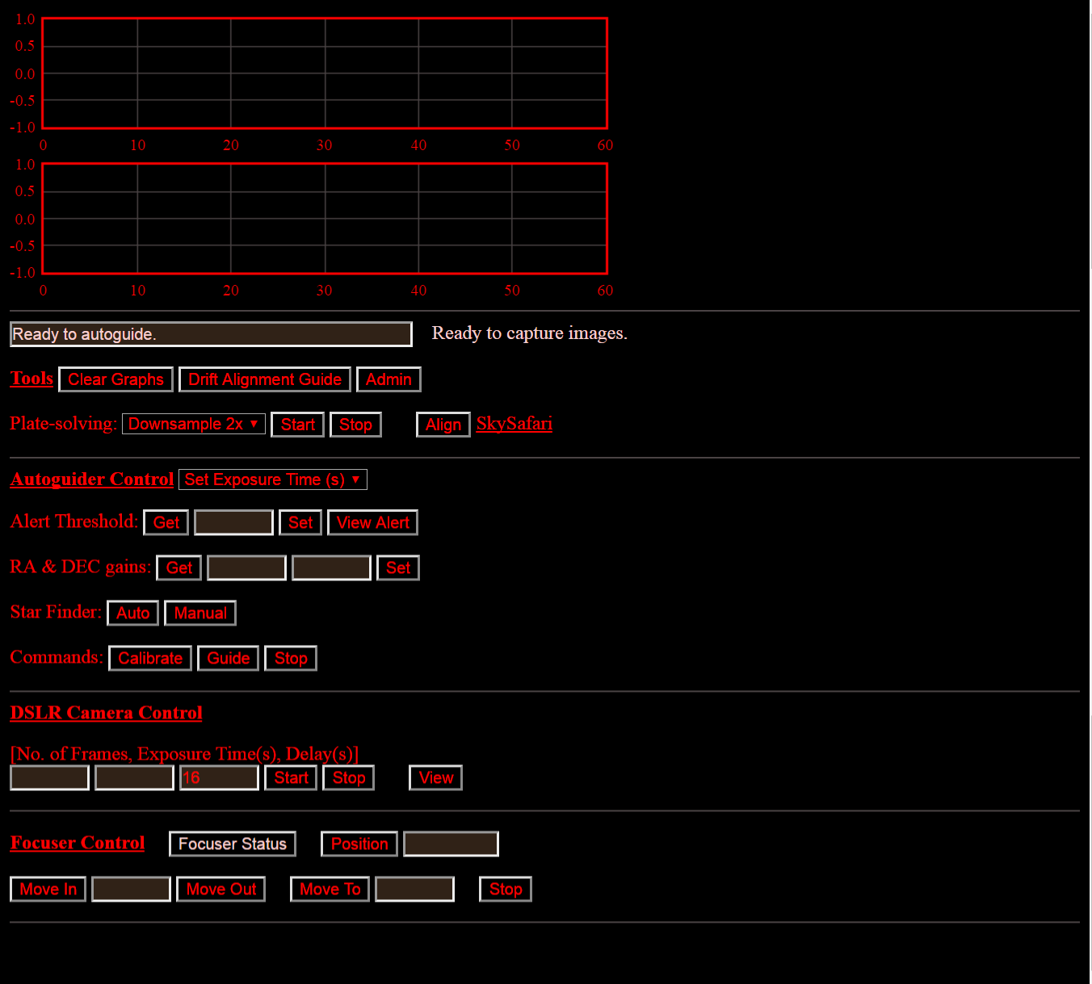

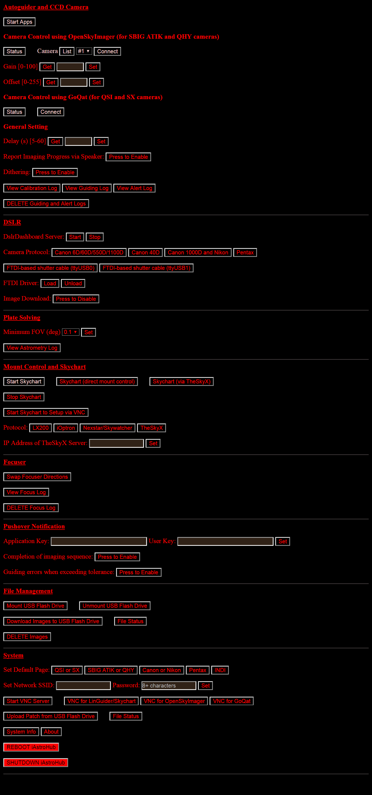

## 2.2 Initial Setup

### 2.2.1 Autoguiding

**NOTE: It is recommended to skip this configuration and revisit after “2.3 First Light” to understand how things work first. Linguider was initially configured to show a simulated star image which is good enough to learn.**

* Press "Admin" on the main page
* Press "Start Apps" on the Admin page.
* Press "Start VNC Server"
* Press "VNC for Linguider/Skychart" You will see the Linguider interface.
* Setup your autoguider device:

Setup > Video Settings > Device

Setup > Video Settings > Expo

Setup > Video Settings > Frame

Setup > Video Settings > Focal length. (If preferring the unit of the guiding error as Pixel instead of Arcsec, input the focal length = pixel size (um) x 206.27)

Setup > Pulse Device Settings > Device

Processing > Calibration > Check "auto mode" and "two axis" (if guiding both axes)

* Exit Linguider in order to save the configuration file.

The configuration for Linguider is completed. This configuration is no longer needed again.

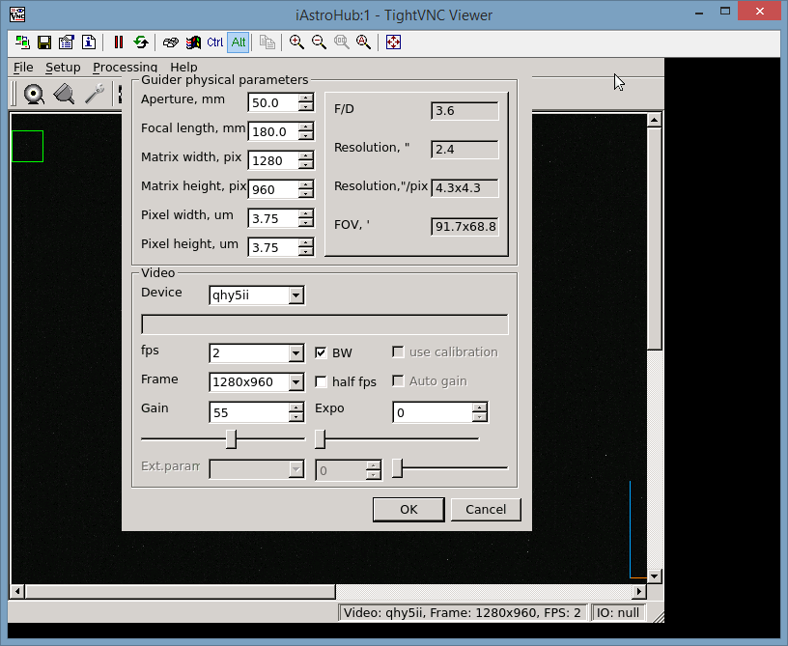

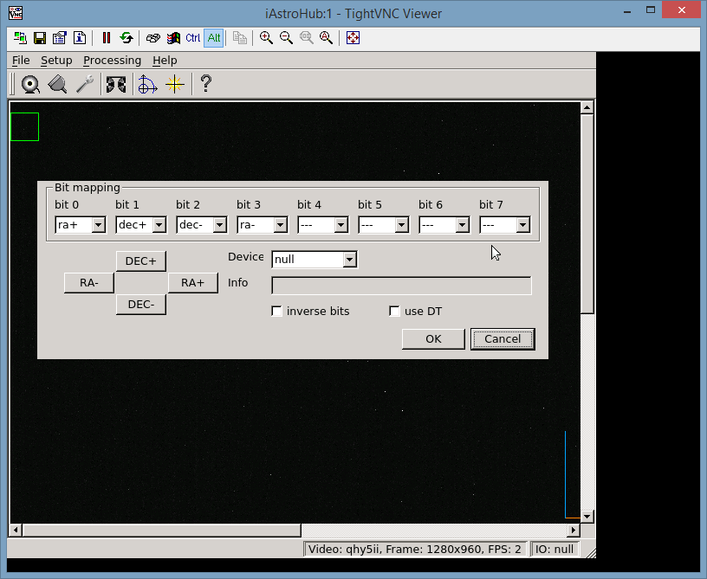

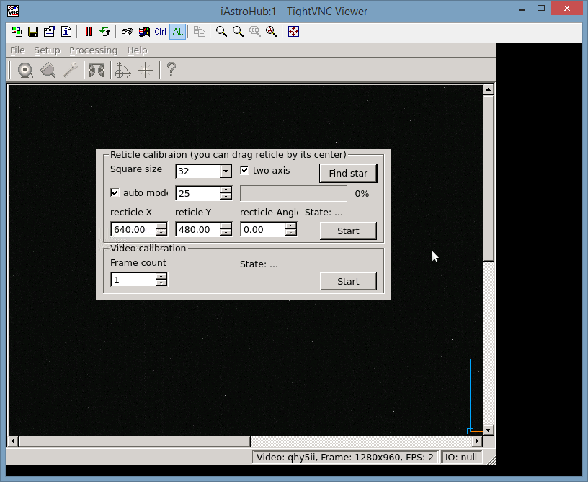

### 2.2.2 Skychart

* Press "Start Skychart to Setup via VNC" on the Admin page.
* Press "VNC for LinGuider/Skychart".
* Setup > Observatory : Setup the observation site
* Exit and save setting

### 2.2.3 Setting file of SkySafari

iAstroHub works as a serial to TCP bridge between a mount and SkySafari. SkySafari can connect to the mount on RPi3 at **Port 3300, IP 10.0.0.1.**

By customizing the skyset file for SkySafari, plate-solving results (FOV and orientation) can be shown on SkySafari. iAstroHub automatically "cooks" your SkySafari setting file (.skyset) using the plate-solving result. Follow these steps:

* Save the Skysafari setting file (.skyset). The setting file contains the FOV of the imaging equipment, mount protocol, and display setting.
* Download the file to the PC.
* Rename the skyset file as "setting.skyset"
* Copy the file to a USB flash drive inside a folder “www”. So the file is located at  
   X:/www/setting.skyset
* Insert the USB flash drive to RPi3
* Press “Upload Patch from USB Flash Drive” on Admin page. It is done!

Now, iAstroHub is ready to control astrophotography devices from a tablet.

## 2.3 First Light

* Use a web browser in a mobile device to access the main page at <http://10.0.0.1/>
* Press “Admin”
* Press "Start Apps" on the Admin page to start autoguiding and imaging programs in the background
* On the main page, set the RA & DEC gains. (set 0 when doing the drift alignment, and set the value as 100 when guiding)
* Press "Manual" to open a star finder page. Press "Auto" to choose a star automatically.
* On the star finder page, choose a star by dragging the star and lift the finger. The position is registered when dragging stops. Then press "Set position"
* Back to the main page, press "Calibration" and wait until the process is completed.
* Press "autoguide". The guiding error graph will show on the top.
* While the mount is autoguided, set the imaging sequence in Camera Control. Specify the exposure time, number of frames and start the sequence.

Note that the tablet can sleep anytime. When the tablet is turned on, the progress will be updated.

**NOTE: After completing the imaging session, remember to SHUTDOWN RPi3. The SHUTDOWN button is at the bottom of the Admin page. If RPi3 is not properly shut down, the micro SD card can be damaged.**

# Understanding Main Pages

## Autoguiding

The following figure is the main interface for Autoguiding. The guiding errors in X and Y axes are shown on the top. The status of the autoguider and the camera is displayed below the graphs.

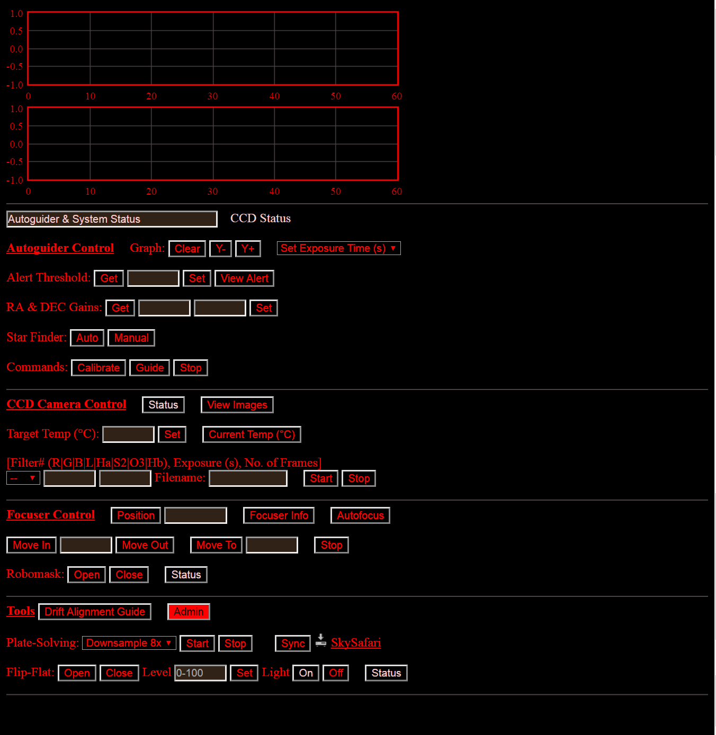



* A user can clear the graph and change the exposure time.
* When a guiding error exceed the Alert Threshold, the error will be logged and notified (if Pushover Notification is enabled). A user can see the alert log by pressing “View Alert”
* RA and DEC gains have the range from zero to infinity. The higher the gain, the more aggressive the correction is. It is recommended to start with 100. When the gain is set to Zero, there is no correction. It is useful for performing drift alignment. The drift alignment guide is available at the “Tools” section. Note that it is for the northern hemisphere.

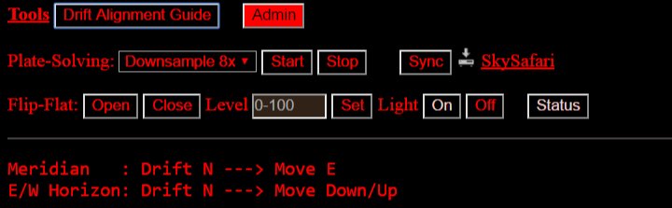

* Star Finder is used to select a star for autoguiding. Auto = automatic selection. Manual = selection by a user. “Manual” will bring a user to a new page as below. A user can adjust the Video gain. To select a star, **DRAG AND STOP** on a star. The position will be shown. Then press “Set Position”. Once it is correctly set, the green square will cover around the selected star.

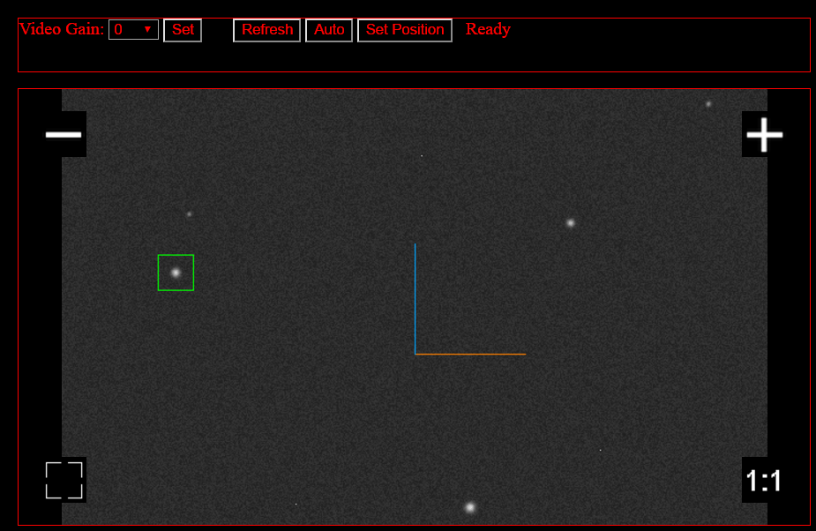

* Go back on the main page and press on **Calibrate** to start the alignment of the correction axes. It take a few minutes. When the calibration process is done, the following log is displayed at the bottom of the page.

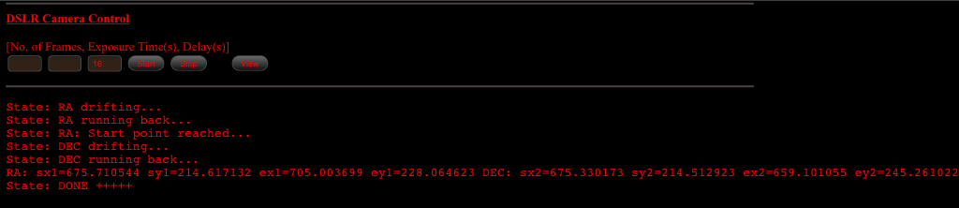

* If the star finder page is refreshed after calibration, the actual RA and DEC axes of the mount will be shown on the star as below

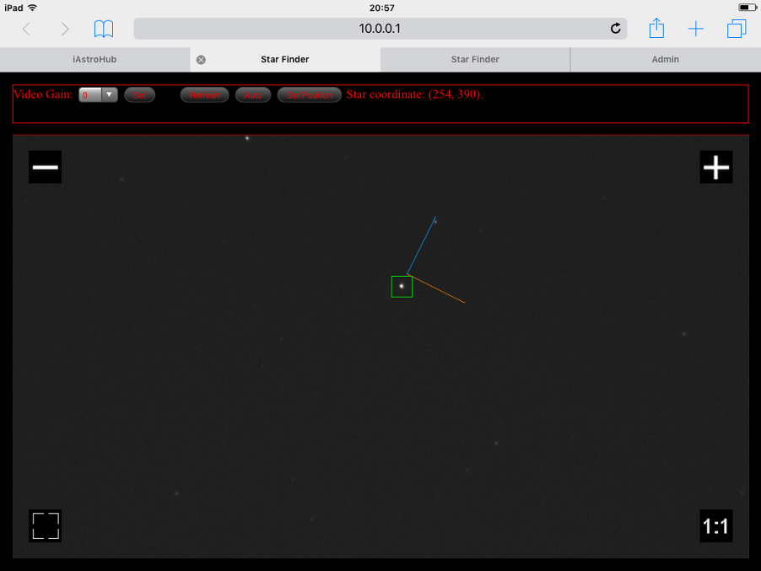

* Press on **Guide** to start the autoguiding. The guiding error will be displayed on the graph.

## Camera control

The camera control panel depends on the “Default Page” selected in the Admin Page: Canon/Nikon, Pentax, QSI SX, SBIG ATIK QHY, or INDI camera.

### DSLR Camera (Canon, Nikon, or Pentax)

Before start controlling the camera, The camera must be configured as:

* + Manual mode
  + Bulb exposure
  + RAW + JPG images

To control the camera, enter the “No. of Frames” and “Exposure Time” in the following space. Press “Start” The progress will be shown on the camera status below the guiding error graphs. The imaging sequence can be terminated by pressing “Stop”.



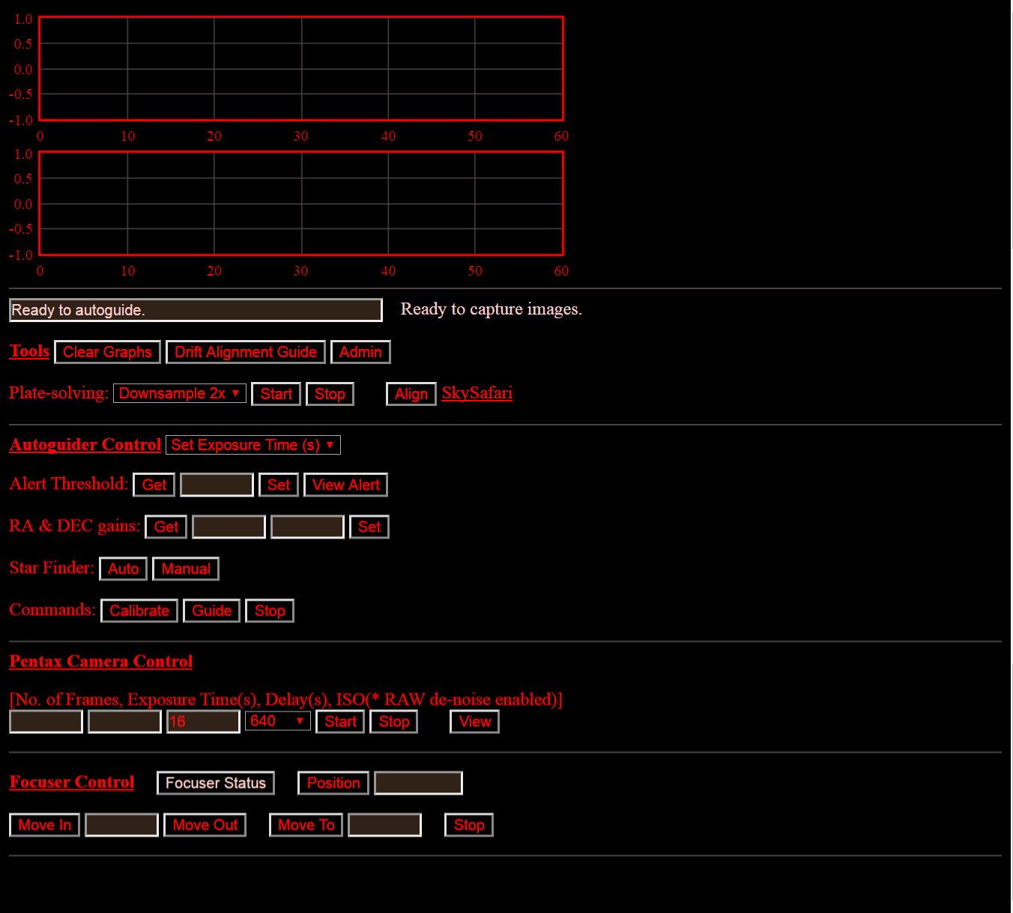

To view the image, press “View”. The new page will open as shown below. Preview images can be selected in the drop-down list.

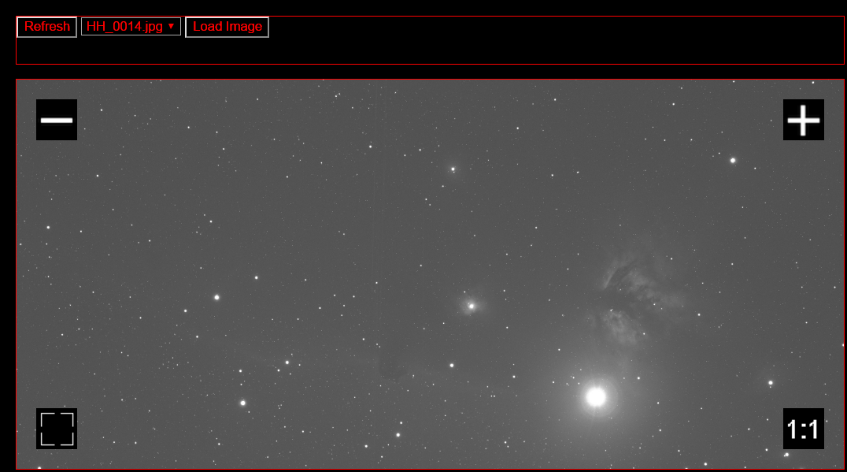

### QSI and SX Cameras

**Note: Before using this Camera Control interface, start apps and connect to the camera in the Admin page first. Read “Understanding the Admin page”**

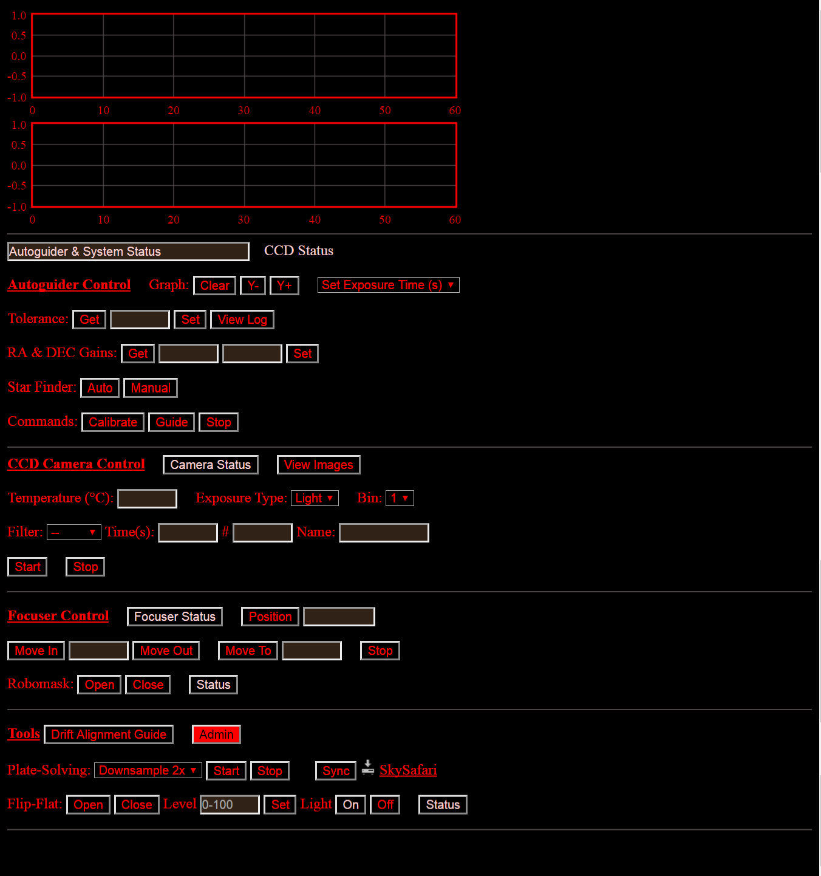

A user can set the following parameters:

- Temperature

- Exposure type (Light or Dark)

- Bin

- Filter

- Exposure time

- Number of frames

- Filename prefix

**Camera Status** will show the current status at the bottom of the page.

**View Images** will open the image viewer as shown below. The histogram can be set to see the detail of objects.

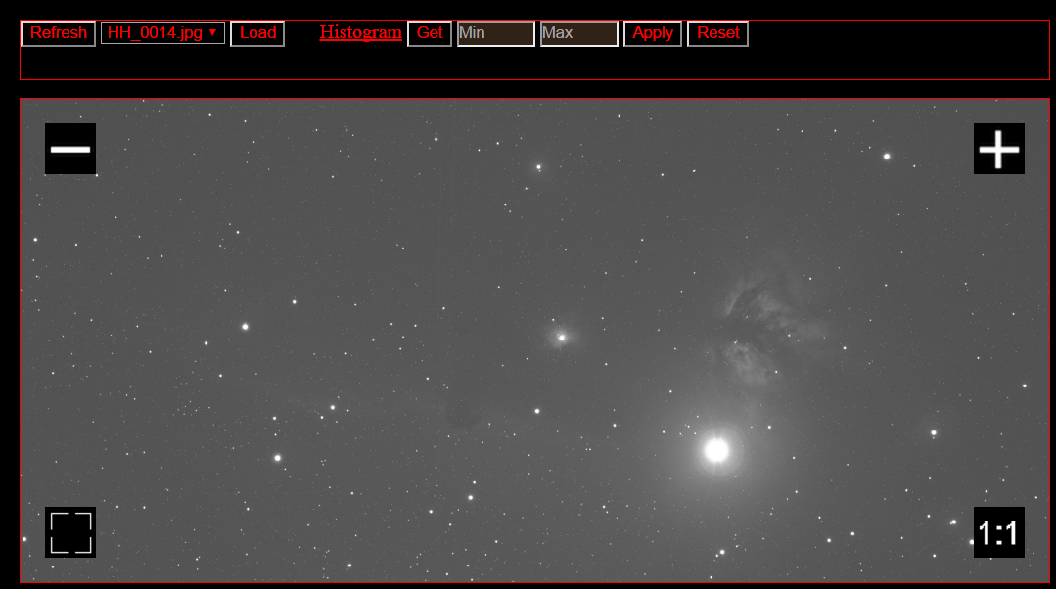

### SBIG, ATIK, and QHY Cameras

**Note: Before using this Camera Control interface, start apps and connect to the camera in the Admin page first. Read “Understanding the Admin page”**



A user can set the following parameters:

- Temperature

- Filter

- Exposure time

- Number of frames

- Filename prefix

**Status** will show the current status at the bottom of the page.

**View Images** will open the image viewer as described above.

### INDI-Compatible Cameras and Devices

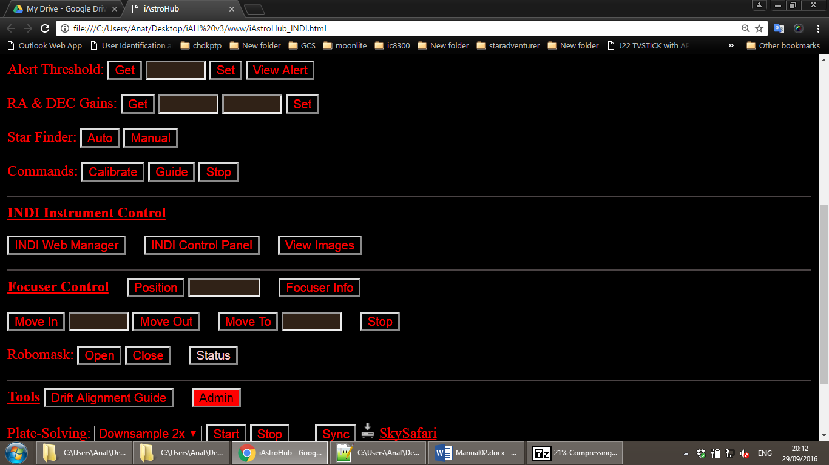

**INDI Web Manager** will open a dedicated page to start the server for INDI-compatible devices (CCD camera, filter wheel, focuser, etc.). It is recommended to use “Imager Agent” which can manage the CCD camera and filter wheel simultaneously. So, various combinations of filter colors and exposure time can be controlled.

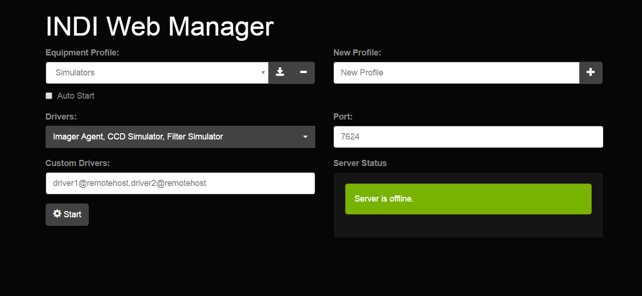

**INDI Control Panel** will open a dedicated page to control devices (CCD camera, filter wheel, etc.).

**Imager Agent** is shown below. Before pressing “Connect”, Text boxes under “Controlled Devices” must be correctly filled. Fill the driver name of the CCD camera and filter wheel. It is the same as those shown in the drop down list of **INDI Web Manager.** Then press “Connect”.

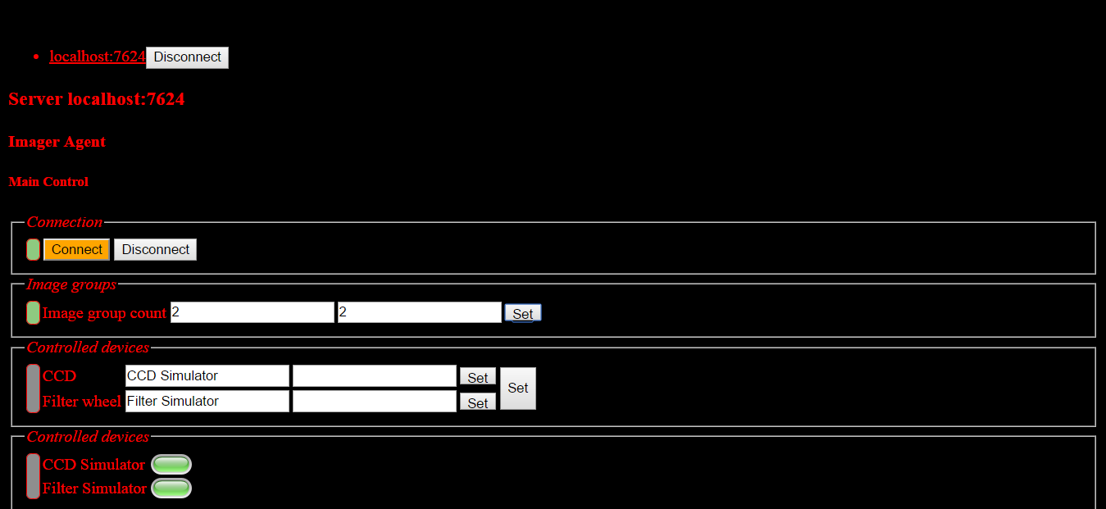

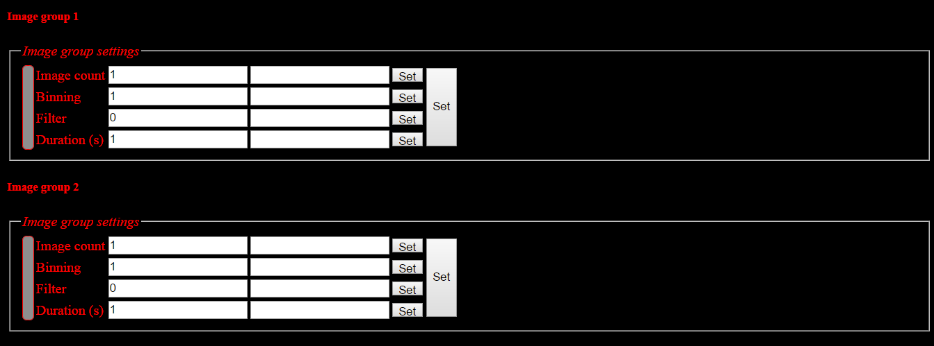

The above figures show Image group count and Image groups to be set. A user can set various combinations of exposure time, bin, filter, and number of frames.

The default image folder is shown below. It is important to keep the image folder name unchanged. The fits files saved to the folder will be ready to preview later. The image prefix can be changed.

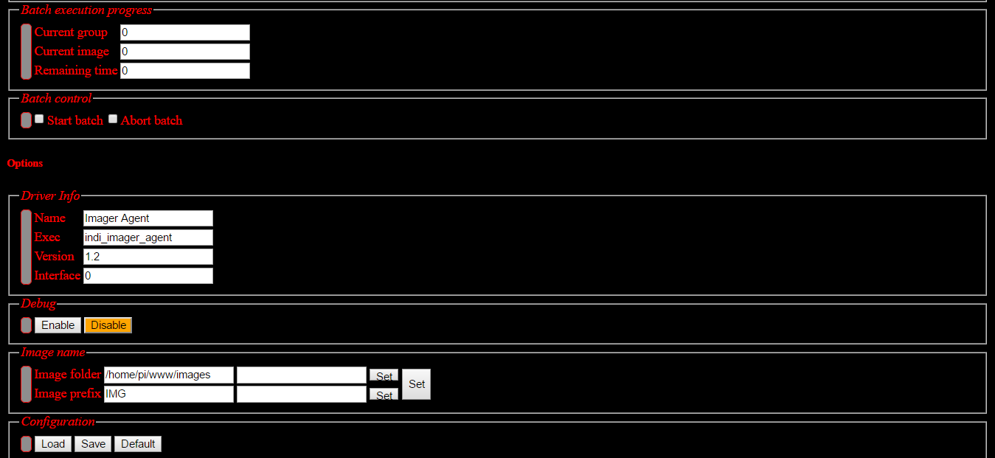

That is all for Imager Agent. The next is to set the CCD temperature as shown below.

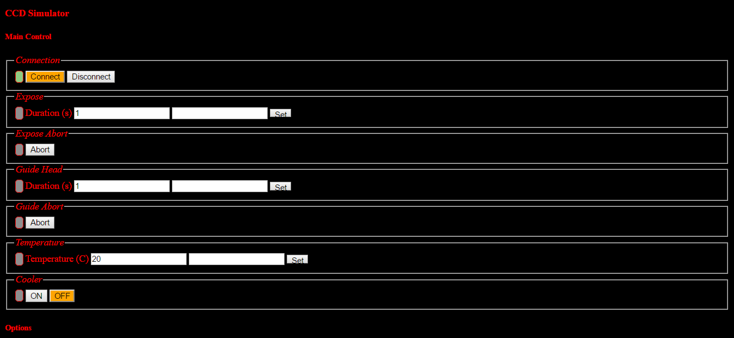

The filter wheel slot name can be manually changed as below.

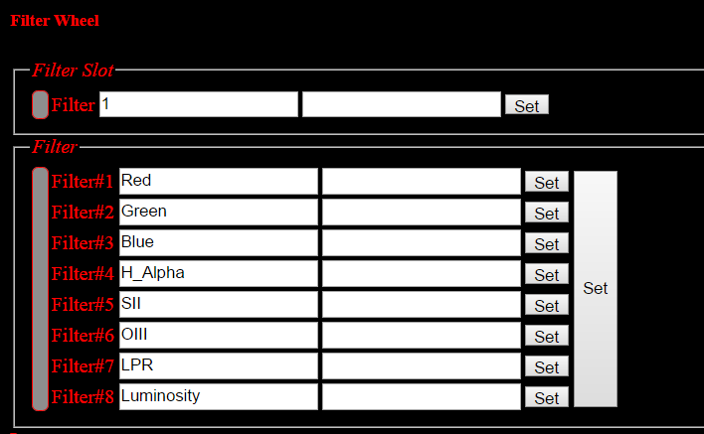

Then it is ready to start the image group. Press “Start batch” at Batch Control. The progress is reported as shown below:

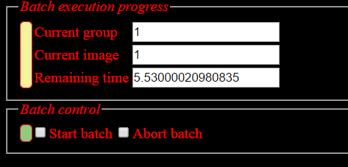

Images are saved in /home/pi/www/images. Images is in the FITS format. In the image viewer, there is an option to “Load FITS” which will load the fits file and convert to a JPG file. Then the JPG file can be viewed later using “Load JPG”. The histogram tool is also provided.

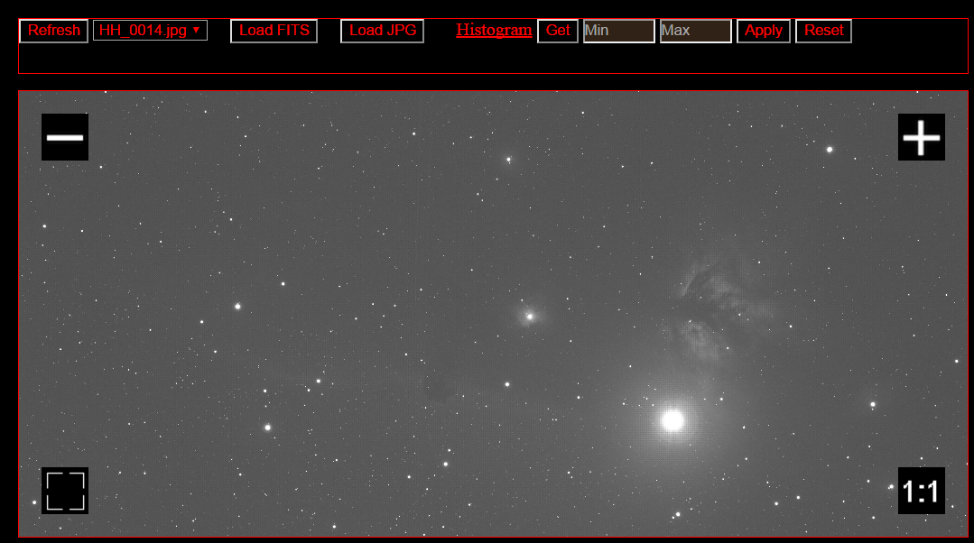

## Plate-solving, sync, and link to SkySafari

Once, the image is shown on the image viewer. It is ready to find the coordinate and orientation of the image by plate-solving using the astrometry.net engine. Plate-solving is very useful for aligning the mount before pointing to a nearby object. So, the target object will be centered.



Select “Downsample” to reduce the resolution of the original image. “Downsample 8x” generally works well. If the image has a low resolution, it is all right to use a lower downsample value. Then press “Start”. Look at the progress at the bottom of the page as show below.

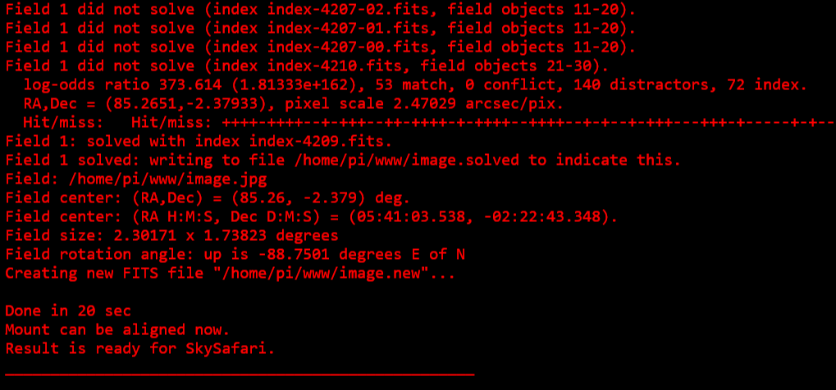

Then the mount can be aligned using the coordinate as shown in the figure. Note that the coordinate from Astrometry.net is in J2000. iAstroHub converts the J2000 coordinate to the JNow coordinate before alignment. Note that the mount protocol must be selected correctly in the Admin page. By pressing “Sync”, the mount coordinate will be adjusted to the coordinate from plate solving.

SkySafari is very popular and powerful for tablets and smartphones. The orientation of the FOV and the coordinate can be shown in SkySafari. Make sure that the web browser which supports file download is used (for example: Chrome, Dolphin). By pressing “SkySafari”, the skyset file will be downloaded to the web browser. Then open the file in Skysafari.

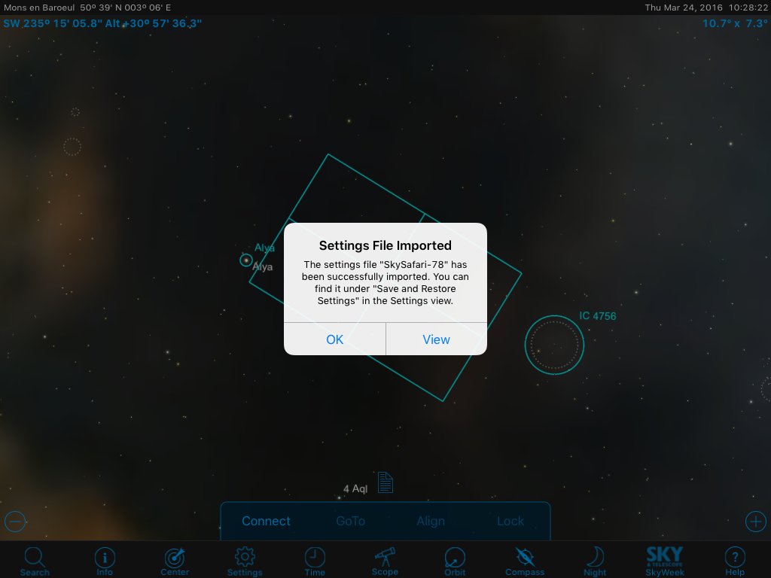

In SkySafari,

* + Connect the mount
  + The position at the center is that from the mount. If the mount is synched in iAstroHub, the position is the same as the plate-solving solution.
  + In Settings section, apply the imported skyset file.
  + Now the position and FOV displayed in the sky is that from the plate-solving. If the mount has not been synched, the offset can be seen.
  + Swipe at the word “Target:” in the upper right corner of SkySafari.
  + Then align the mount to Target: Center

A sample result is shown below. In this example, it is necessary to rotate the camera to frame the California Nebula. It is obviously the benefit of plate-solving and the integration with SkySafari.

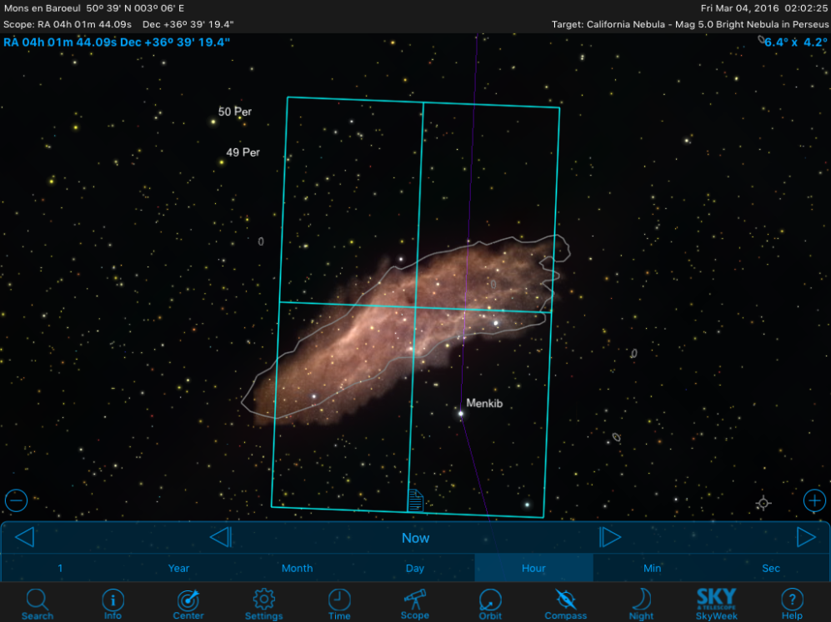

**How to speed up plate-solving**

1) Set the FOV in the Admin page

2) Set Downsample. The downsample value will reduce the number of stars in the original image. It is faster if the number of star sources is reduced to about 100 – 500.

3) The astrometry.net engine uses star database with different FOVs. The index files 4207 – 4210 are provided in iAstroHub. The index files cover the FOV of 0.5 – 1.5 deg. The fewer files, the faster the calculation is. So use the smaller number of index files if the FOV of the setup is fixed.

The index files can be download from <http://astrometry.net/doc/readme.html>

Then upload the index files to /usr/local/astrometry/data/

## Focuser

A control interface for Robofocus is shown below. A user can precisely control the position of the focuser using the commands: Move in, Move out, Move to.



Robomask is the DIY solution to remotely control a Bahtinov mask. Robomask is made from the servo motor controller (Yocto-servo) and a servo motor (DFrobot DSS-M15 180deg) to “Open” and “Close” the bahtinov mask remotely.

There is a tool for autofocus. The V-curve is generated by moving the focuser to various positions and computing the half-flux diameter (HFD) of a star. Then the focuser is moved to the position of the lowest HFD. The interface is shown below.

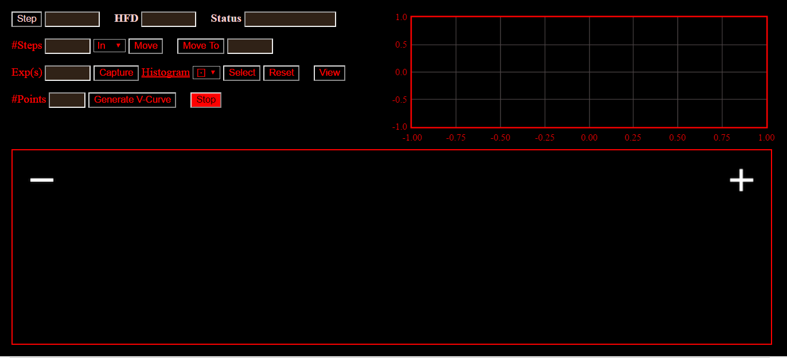

## 3.5 Flip-Flat

Flip-Flat is used to provide a uniform light source when taking flat frames remotely. The control panel is shown below. It is possible to open and close the flip-flat and adjust its brightness.



## 3.6 Skychart

**NOTE: Skychart is accessed from the Admin page.**

Skychart is the web interface of Skychart or Cartes du Ciel (<https://www.ap-i.net/skychart/en/start>). A user can search for an object and control a mount to go to or sync to the object. The interface is shown below.

## 

There are various commands as follows:

## 

The result of plate solving can be displayed in Skychart. Then the mount can be synched to the position.

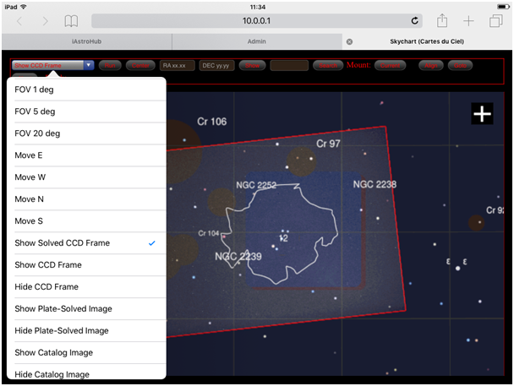

# Understanding the Admin Page

## Autoguider and CCD Camera

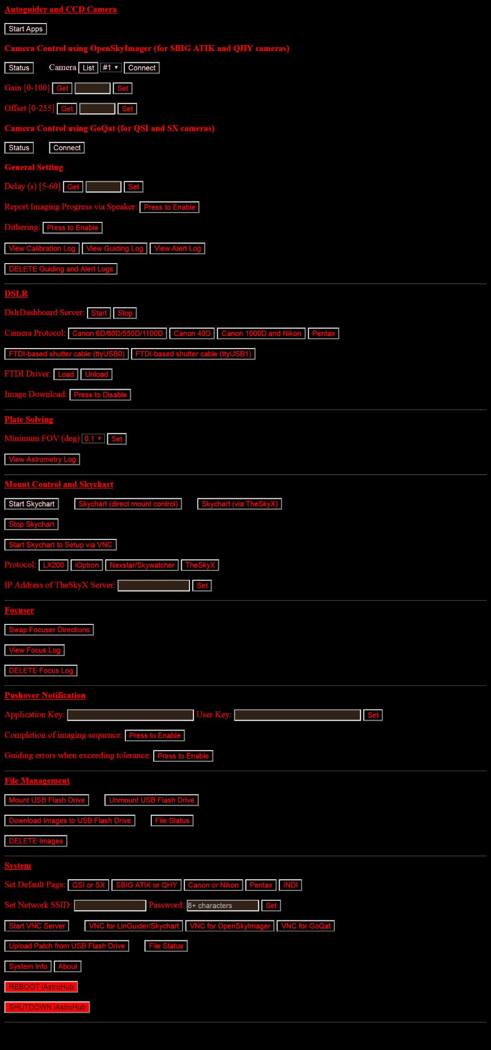

This is the main part to start main programs and connect to cameras.

**Start Apps** is the first button to press after turning on RPi3. It will start Linguider, OpenSkyImager, GoQat, INDI server and client.

**Status** will show the boot status of OpenSkyImager and GoQat. Wait until the status is as follows:

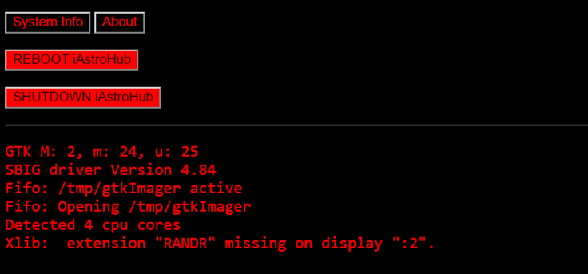

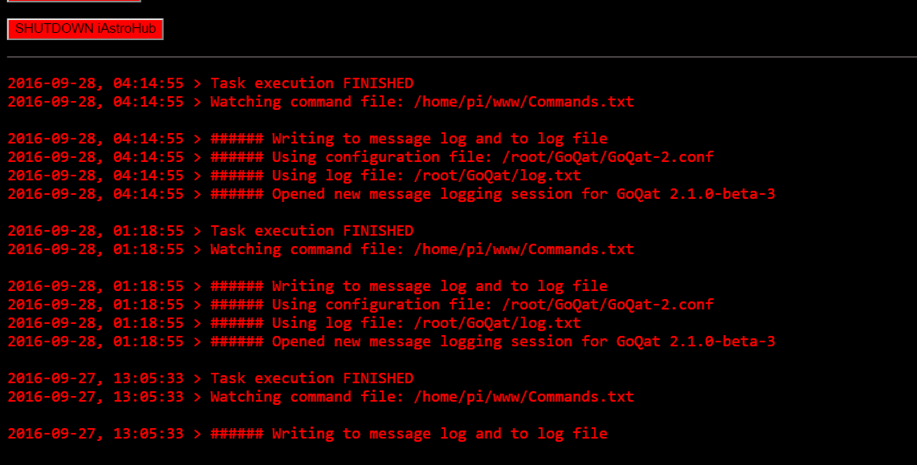

After the programs are loaded, a user can **connect** the camera. For OpenSkyImage, Select the camera for imaging. Press “**List**” to see how the camera is numbered.

It is possible to set **Gain** and **Offset** for QHY cameras. Read this article about the gain and offset.  
http://www.stark-labs.com/help/blog/files/GainAndOffset.php

**Delay (s)** is the time between images.

**Report Imaging Progress via Speaker**: If enabled, RPi3 will speak the imaging progress.

**Dithering:** If enabled, a small movement (a few pixels) will be introduced between each image. It is useful for reducing noises.

The user can view **Calibration Log, Guiding Log, and Alert Log** if pressing the provided buttons.

## DSLR Camera



**DslrDashboard Server**: If started, a supported Canon or Nikon camera can be controlled using qDslrDashboard (available on iOS and Android). When starting qDslrDashboard, long press on this button 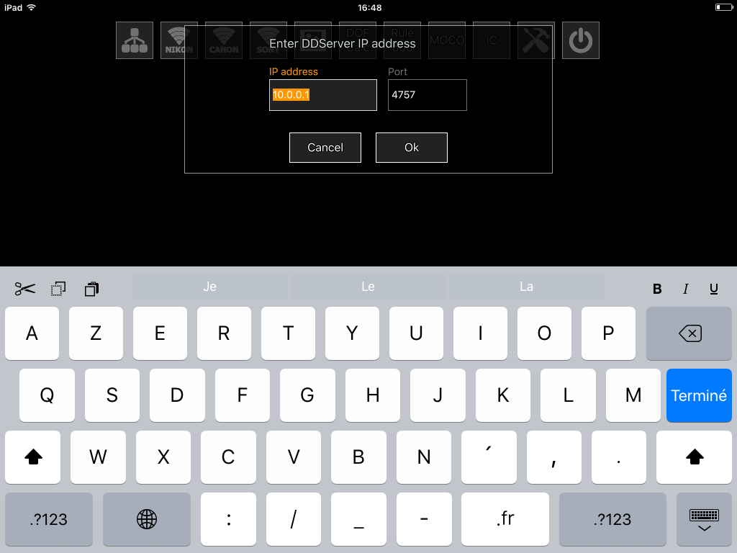, enter IP 10.0.0.1, Port 4757 and press **OK.**



Now, it is possible to control all DSLR settings and display the Live View. It is useful for focusing or changing the setting values in the camera.

To close the software,Press on and press “Stop”on the Admin page. For more details, refer to <http://dslrdashboard.info/>

**Camera Protocol**: Choose the proper camera protocol.

The FTDI-based shutter cable is used for old cameras (before Canon 450D) which cannot be controlled in the bulb mode by a single USB cable. The serial shutter cable can be made as shown in the diagram (Thanks to Matthew Chang for granting the permission to include the diagram in this manual).

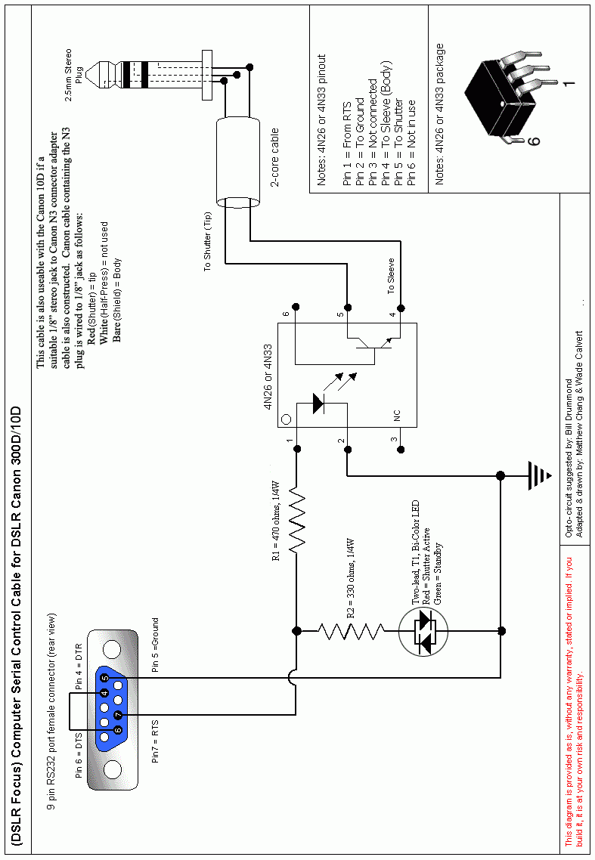

**FTDI driver:** The FTDI driver needs to be loaded manually. It is because some CCD cameras or devices (Flip-flat) use FTDI chips but don't want the FTDI driver. The steps are as follows:

* Press “Load”
* Insert the FTDI-based USB-serial cable
* Once done, press “Unload”
* Disconnect the FTDI-based USB-serial cable

**Image Download**: A user can disable the image download.

## Plate-solving



The field of view (FOV) can be set here. And it is possible to view the latest log of plate-solving.

## Mount Control and Skychart



**Start Skychart:** This commands will start Skychart

**Skychart (direct mount control):** This button will open a Skychart page. The mount is controlled using the LX200, iOptron, or Nexstar/Skywatcher protocol.

**Skychart (via TheSkyX):** This button will open another Skychart page. The mount is controlled using TheSkyX’s protocol. The commands will be send through TCP/IP. So it is needed to set the IP address of the TheSkyX server. This protocol is mainly used for Paramount mounts.

**Stop Skychart:** This command will stop Skychart

**Start Skychart to Setup via VNC:** This is used only for initial setup. See Section 2.

**Protocol:** Choose the protocol of the mount.

## Focuser



A user can view/delete the focus log. And the focuser direction can be swapped to match the mechanical setup.

## Pushover Notification



If RPi3 is connected to internet either via an Ethernet port or USB-tethering from a smartphone, it is capable to send notifications when

* the imaging sequence is completed
* the guiding error is larger than a threshold

Pushover (<https://pushover.net/>) is available in iOS and Android for US$ 5. There is no other service fee. So a user will get notifications pushed to smartphones (iOS and Android), Apple Watch, Android Wear, or Pebble Watch. After registration at the website, copy and paste the required keys here.

## File Management



Images captured by a camera are stored in the micro SD card in RPi3 at /home/pi/www/images. However, it is possible to have all images stored in a USB flash drive from the beginning. So, before the imaging session, insert the USB flash drive and press “**Mount USB Flash Drive**”. All files will be stored in the drive. Press “**Unmount USB Flash Drive**” after finishing the session and then remove the drive.

If the images are stored inside the micro SD card, there are two options to get the images:

1. Use an SFTP client to download the image. Connect to 10.0.0.1 and use  
   username = root  
   password = raspberry
2. Or use the command **Download Images to USB Flash Drive**. Simply insert a USB flash drive to a USB port and press the button. Wait until the LED on the drive stops blinking or press “**File Status**” to see the progress. When it is done, File Status will return DONE at the bottom status bar.

**DELETE images:** This command will erase all files inside /home/pi/www/images. There is a warning window before executing the command. But BE CAREFUL.

## System



**Set Default Page:** This command will change the main page to match the main camera used. After pressing this command, please refresh the main page.

**Set Network:** The default SSID is iAstroHub and the password is 1234512345123. The SSID and password can be changed using this command. The SSID and password shall not have any space or special character.

**Start VNC Server:** This command will start the VNC server to interact with the core programs used in iAstroHub.

**VNC for LinGuider/Skychart:** It will open the following page. This is mainly used for initial setup or debugging.

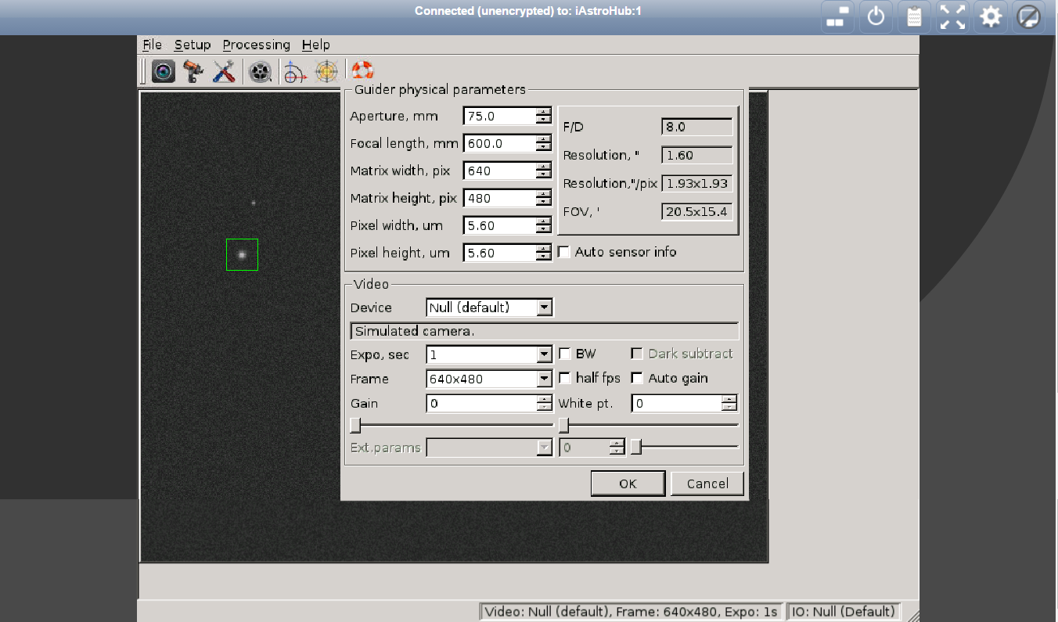

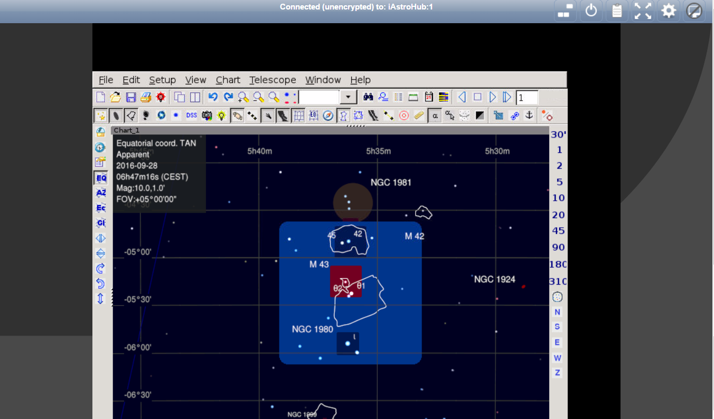

**VNC for OpenSkyImager**: It will open the following page. This is mainly used for initial setup or debugging.

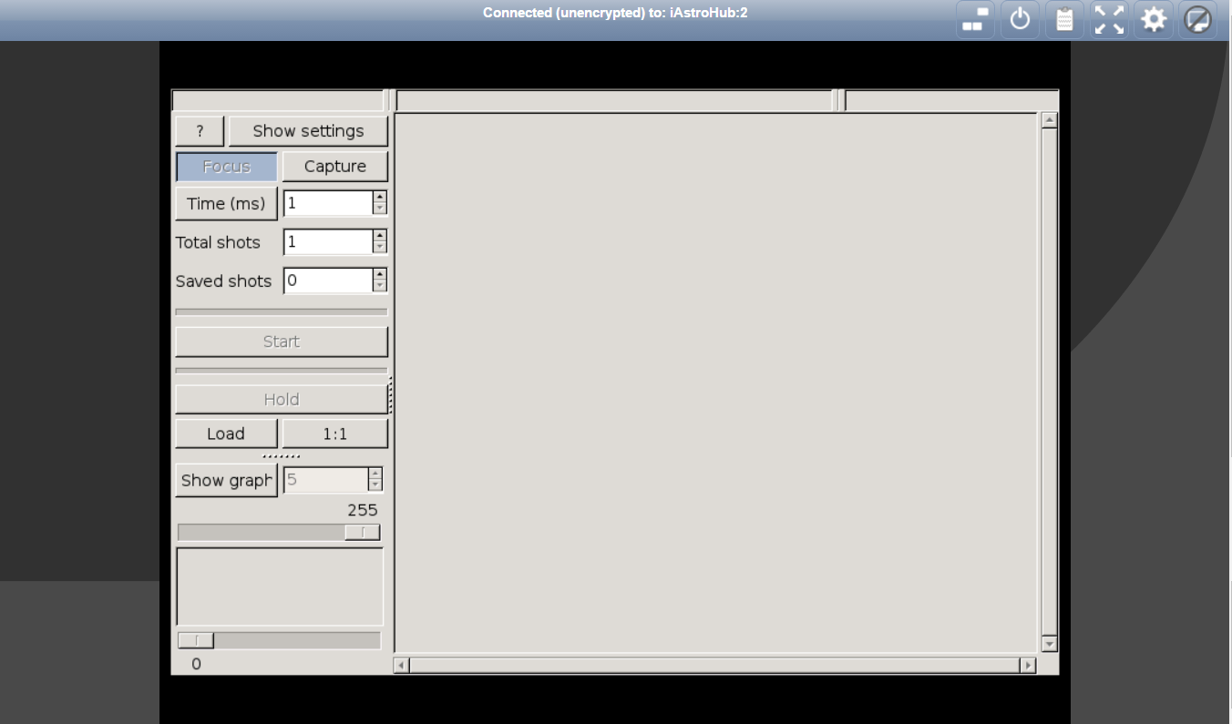

**VNC for GoQat:** It will open the following page. This is mainly used for initial setup or debugging.

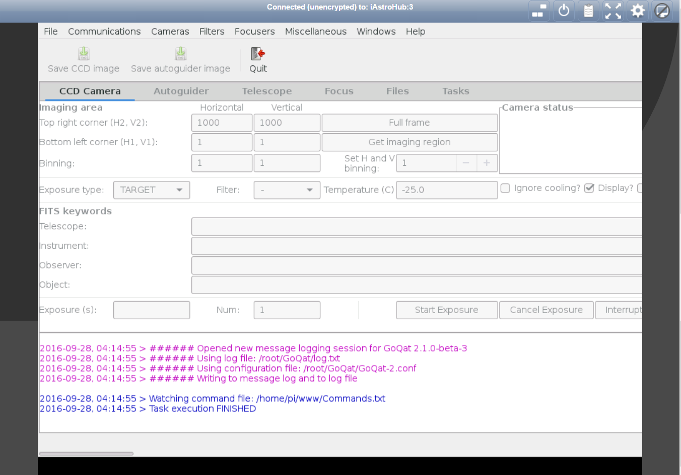

**Upload Patch from USB Flash Drive:**

When there is a patch in the future, there is no longer need to use SFTP to transfer files or run Linux commands manually. Simply copy the patch files to a USB Flash Drive, insert the drive, and press the button. Everything will be done automatically.

**File Status:** This command will show the patching progress at the bottom status bar.

**System Info:** The system information will show on a new page. It is used to check connected devices, available memory, available space, CPU temperature, IP address of the Ethernet port, etc.

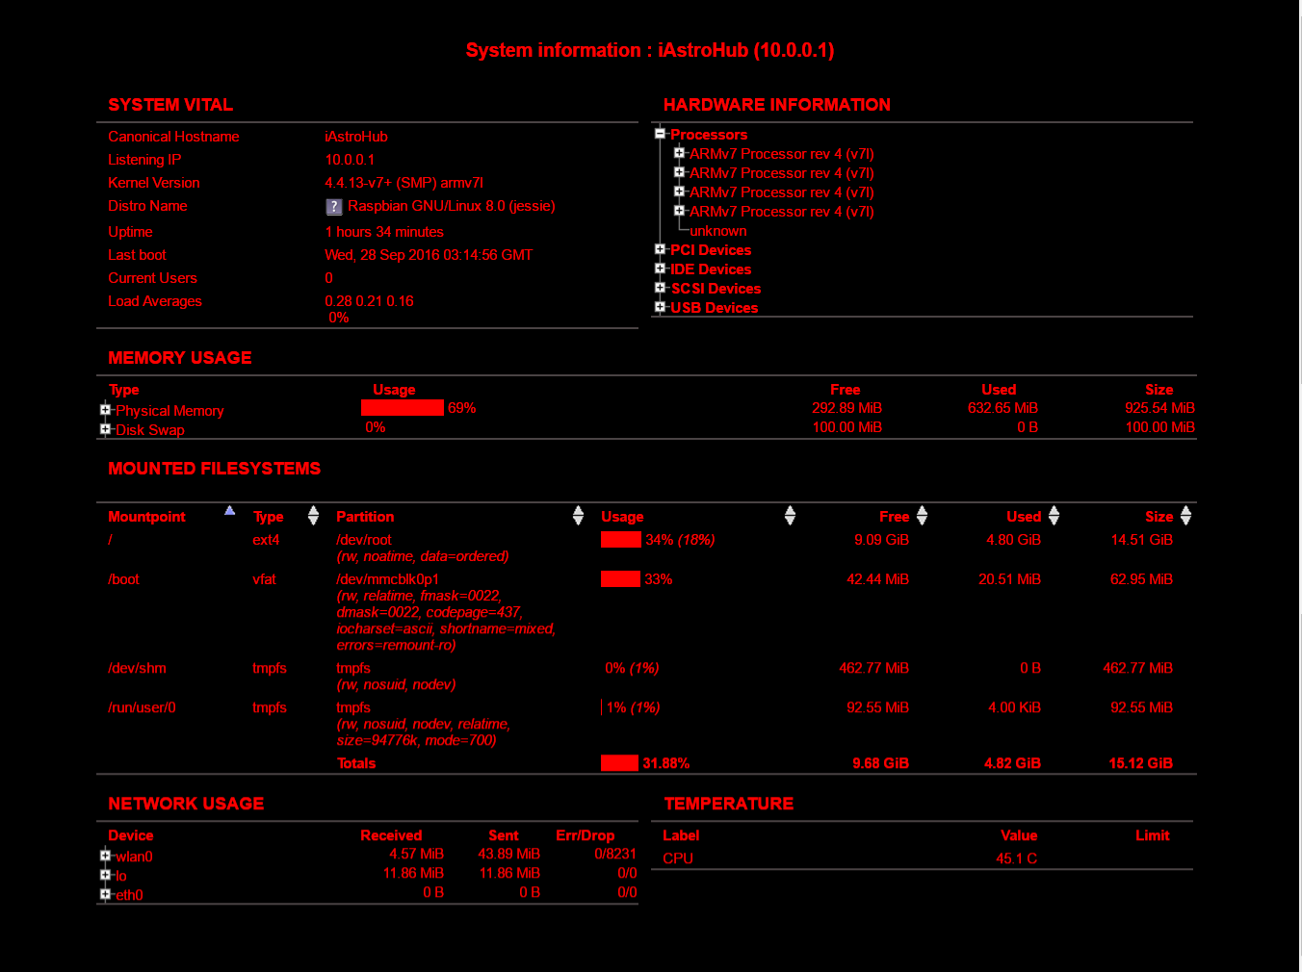

**About:**   
People behind iAstroHub

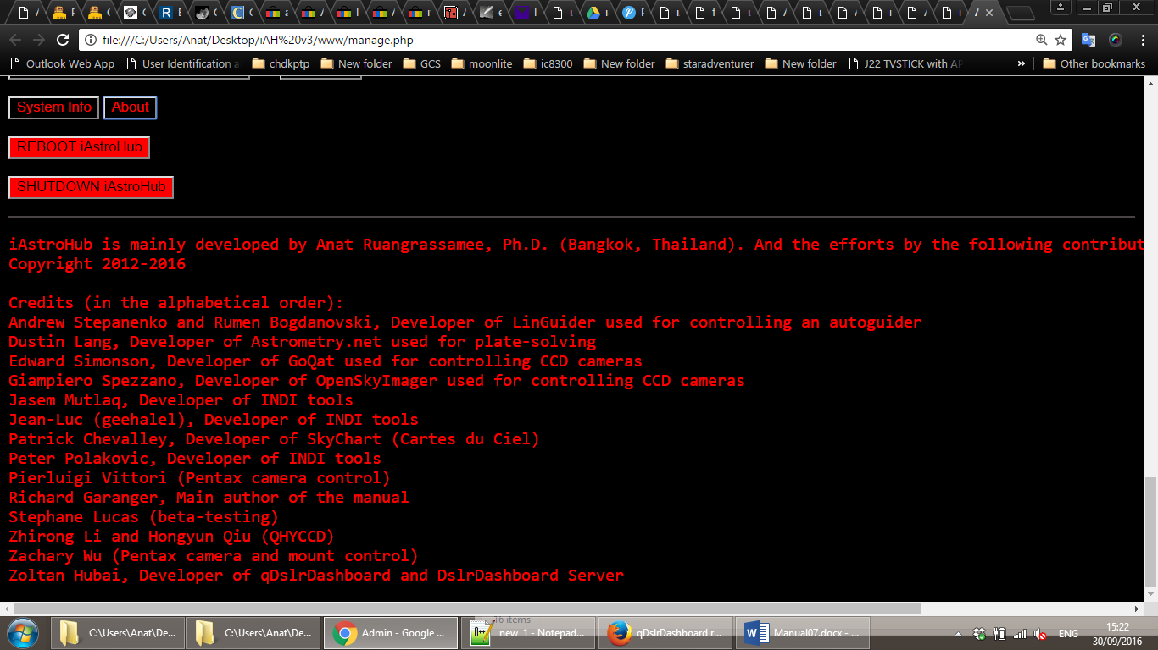

**REBOOT:** This command will reboot RPi3.

**SHUTDOWN:** This command will shut down RPi3. Wait until the LED is off. Then unplug RPi3.

## 5. Useful links

**iAstroHub**

Sourceforge site:

<http://sourceforge.net/projects/iastrohub/>

The first forum post:

<http://www.cloudynights.com/topic/385710-piastrohub-raspberrypi-for-autoguidingdslrgoto/>

the second forum post:

<http://www.cloudynights.com/topic/459674-iastrohub-tablet-astrophotography-comes-true/>

**7-ZIP**

<http://www.7-zip.org/>

**Win32 drive Imager**

<http://sourceforge.net/projects/win32diskimager/>

**MobaXterm**

<http://mobaxterm.mobatek.net/download-home-edition.html>

**Astrometry**

<http://astrometry.net/doc/readme.html>

<http://data.astrometry.net/4200/>

**Applications**

<http://dslrdashboard.info/>

<http://skysafariastronomy.com/products/skysafari/>

<https://pushover.net/>